AI FAQ Assistant AI

AI-powered FAQ and customer support automation.
PROJECT DOCUMENTATION
Submitted By:

Team ID: SWTID-2026-9625

Team Leader: Dharshini U
Team Member: Jaya sri G
Team Member: Priya Dharshini B
Team Member: Jasmine AH

Course: B.Sc. Computer Science with Artificial Intelligence
College: DRBCCC Hindu College
University: University of Madras
Academic Year: 2026-2027

1. Title
AI FAQ Assistant API
The uploaded project package identifies the application as a backend-only REST API for an AI FAQ Assistant. The package description states that it uses Express, MongoDB and Google Gemini.

2. Abstract
The AI FAQ Assistant API is a backend application that provides REST endpoints for user authentication, FAQ management, category management, search, AI-assisted FAQ generation, AI-assisted question answering, and answer feedback. The application is implemented with Node.js and Express.js and uses MongoDB through Mongoose for data persistence. JWT is used for authenticated requests, bcryptjs is used to hash passwords, and Google Gemini is accessed through the @google/genai package for AI features. The project is organized into controllers, middleware, models, routes, and service layers. It is designed as a headless API and can be tested using HTTP clients such as Thunder Client or Postman.

3. Introduction
The project provides a centralized REST API for managing frequently asked questions. It supports different user roles and controls access to private and administrative operations. Public users can access public FAQ information, while authenticated users can access protected functions according to their role.
The backend also provides AI features. Authorized administrators and content creators can submit a prompt to generate an FAQ containing a question, answer, and topic suggestions. Authenticated users can submit a question and receive an AI-generated answer. For this answer operation, up to five matching public FAQs are supplied to Gemini as context.
The project is backend-only. No frontend application files are included in the shared project ZIP.

4. Problem Statement
FAQ information can become difficult to create, organize, update, and retrieve when it is maintained manually. A backend system is required to provide controlled access to FAQ records, organize them by category and tags, support searching, and reduce manual effort in preparing FAQ content.
The project addresses these needs through REST endpoints, database validation, role-based access control, keyword-based search, and Gemini-assisted content generation and answering.

5. Objectives
• Provide REST API endpoints for registration, login, profile access, FAQ operations, category operations, user administration, AI operations, and feedback.
• Store users, FAQs, categories, tags, generated FAQs, and feedback in MongoDB using Mongoose schemas.
• Protect private API operations with JWT authentication and role-based authorization.
• Hash user passwords with bcryptjs before storing them.
• Allow administrators and content creators to generate FAQ content using Google Gemini.
• Allow authenticated users to request AI-assisted answers using public FAQ context.
• Provide keyword-based FAQ search across question, answer, and tags.
• Validate incoming request fields with express-validator and enforce model-level validation with Mongoose.
• Provide centralized error handling and HTTP request logging.
• Control FAQ visibility through the isPublic field and ownership rules.

6. Existing System
The project source does not document a specific external or legacy system. Based on the problem addressed by the application, the relevant traditional approach is manual FAQ preparation and retrieval: users or support/content teams create answers manually, store them in an organized record system, and search through existing information when responding to questions.
This section therefore describes the general manual approach rather than claiming a particular existing product or technology.

7. Proposed System
The proposed system is the implemented AI FAQ Assistant API. It provides a single REST backend that connects HTTP clients with authentication, validation, business logic, MongoDB persistence, search services, and Google Gemini services.
Area | Implemented capability
Authentication | Registration, login, JWT token generation, protected profile access
Authorization | Admin, content_creator, and user roles with route and ownership checks
FAQ | Create, read, update, delete, public/private visibility, tags and view count
Category | Create, read, update and delete categories; public category listing
Search | Keyword-based matching across FAQ question, answer and tags
AI | Generate FAQ drafts and generate answers using Google Gemini
Feedback | Authenticated feedback submission and admin feedback listing
Administration | User listing, role/name/email update, user deletion, full FAQ access

8. System Requirements
Software Requirements
Requirement | Actual project basis
Operating System | No operating-system-specific requirement is stated in the source. The application is a Node.js backend.
Node.js | Required runtime. package.json uses ES modules and Node-based scripts.
npm | Required to install dependencies and execute package scripts.
MongoDB | Required database. config/db.js connects through MONGO_URI.
HTTP client | Thunder Client, Postman, or another REST client can be used for API testing.
Code editor | Visual Studio Code or another JavaScript-capable editor may be used.

Hardware Requirements
The source files do not define a minimum processor, RAM, or storage specification. Therefore, the documentation does not assign an unsupported hardware minimum. The development machine must have enough resources to run Node.js and the selected MongoDB deployment.
Environment Configuration
The local project uses a .env file for sensitive/runtime configuration. The actual values are intentionally excluded from the shared project. The source code references these environment variables: PORT, MONGO_URI, JWT_SECRET, JWT_EXPIRES_IN, GEMINI_API_KEY, GEMINI_MODEL, CLIENT_URL, ADMIN_EMAIL, and ADMIN_PASSWORD.

9. Technologies Used
Technology / Package | Use in the project
Node.js | JavaScript runtime for the backend server
Express.js 5.1.0 | REST API server and routing
MongoDB | NoSQL database
Mongoose 9.0.0 | MongoDB ODM, schemas, validation, references, timestamps and indexes
@google/genai 1.0.0 | Google Gemini integration
jsonwebtoken 9.0.2 | JWT creation and verification
bcryptjs 3.0.2 | Password hashing and password comparison
express-validator 7.2.1 | Request validation
helmet 8.1.0 | HTTP security headers
cors 2.8.5 | CORS configuration
express-rate-limit 8.1.0 | Rate limiting
morgan 1.10.0 | HTTP request logging
dotenv 17.2.2 | Environment configuration loading
nodemon 3.1.10 | Development server auto-restart

10. System Architecture
The actual architecture is a headless REST API. A client such as Thunder Client, Postman, or another HTTP client sends a request to Express. Middleware performs parsing, rate limiting, security handling, validation, authentication, and authorization as required. Route modules call controllers. Controllers use Mongoose models and service modules. MongoDB provides persistent data storage, while the Gemini service communicates with Google Gemini for AI operations.
Layer | Actual project components
Client | Thunder Client, Postman, or another HTTP client
API server | server.js and Express.js
Middleware | authMiddleware.js, validate.js, faqAccess.js, errorMiddleware.js plus Helmet, CORS, Morgan and rate limiting
Routes | authRoutes, faqRoutes, categoryRoutes, aiRoutes, userRoutes, feedbackRoutes
Controllers | auth, FAQ, category, AI, user and feedback controllers
Services | geminiService.js and searchService.js
Database | MongoDB accessed through Mongoose models
External AI | Google Gemini through @google/genai

Architecture flow:
HTTP Client
↓
Express REST API (server.js)
↓
Middleware: parsing / security / rate limit / validation / JWT / authorization
↓
Route modules
↓
Controllers
↓
Services and Mongoose Models
↓ ↓
MongoDB Google Gemini
There is no frontend layer in the uploaded project package.

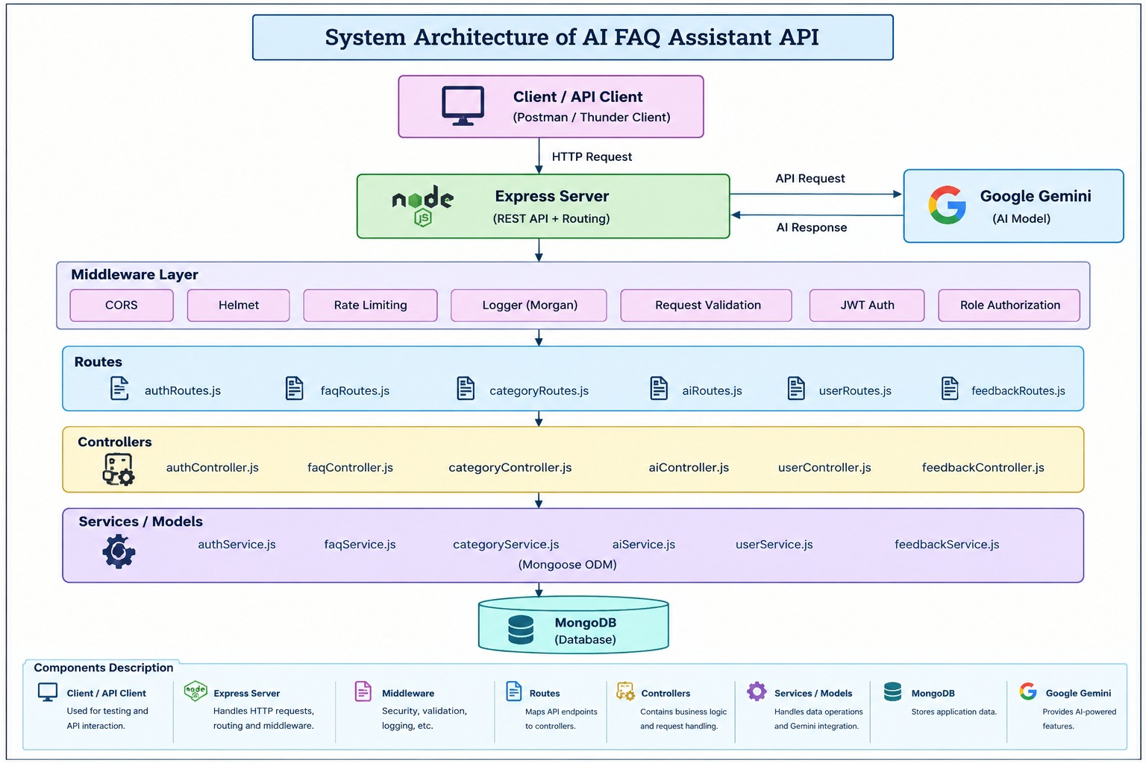

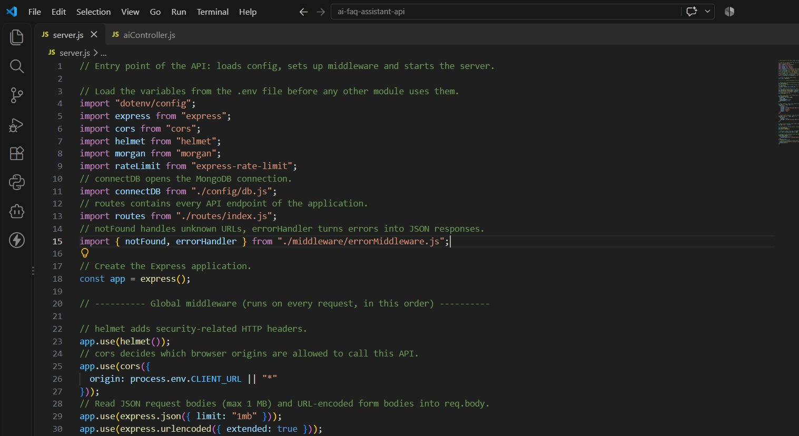

11. Database Design
The application uses MongoDB with Mongoose. The project defines seven Mongoose models.
Model / Collection | Important fields and rules
User | name, email, password, role, timestamps. Email is unique and lowercased. Password is excluded from normal selection and hashed with bcryptjs. Role is admin, content_creator, or user.
FAQ | userId, categoryId, question, answer, tags, isPublic, views, timestamps. Question length is 5–500 characters; answer length is 2–5000; views cannot be negative.
Category | name, description, timestamps. Name is required, unique, trimmed, and max 100 characters; description max 500.
Tag | name, timestamps. Name is required, unique, trimmed, lowercased, max 50 characters.
FAQTag | faqId, tagId, timestamps. A unique compound index prevents the same FAQ/tag pair from being duplicated.
AIGeneratedFAQ | userId, prompt, question, answer, topicSuggestions, status, savedFaqId, timestamps. Status is generated or saved.
AnswerFeedback | faqId, userId, helpful, comment, timestamps. Comment is optional and max 500 characters.

Relationships
• User → FAQ: one user can create multiple FAQs through FAQ.userId.
• Category → FAQ: multiple FAQs can reference a category through FAQ.categoryId.
• FAQ ↔ Tag: FAQTag provides a many-to-many mapping between FAQ and Tag.
• User → AIGeneratedFAQ: one user can create multiple AI-generated FAQ records.
• AIGeneratedFAQ → FAQ: savedFaqId can reference the FAQ created from a generated record.
• FAQ → AnswerFeedback and User → AnswerFeedback: feedback records reference both the FAQ and the submitting user.
• Search results are generated dynamically; there is no separate SearchResults collection.
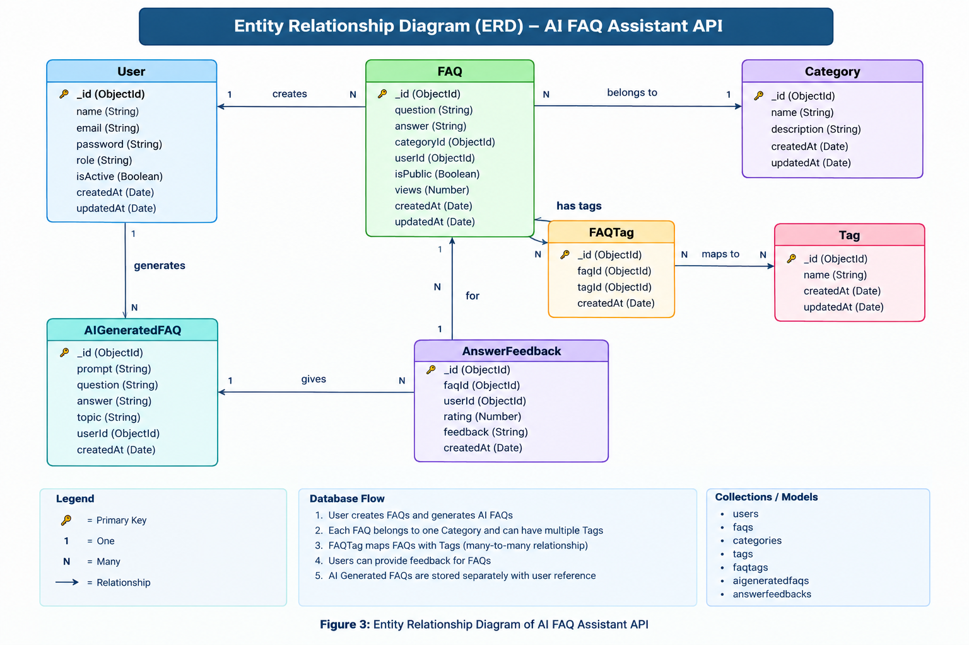

12. Modules
Module | Purpose | Main functionality
Authentication | Manage identity | Register, login, JWT creation, protected profile
User Administration | Manage users | Admin-only list, update and delete operations
FAQ Management | Manage FAQ records | Create, list, view, update, delete, ownership, visibility and views
Category Management | Organize FAQs | Create, list, update and delete categories
Tag Management within FAQ | Maintain tag mappings | Normalize tags and synchronize FAQTag records during FAQ create/update
AI FAQ Generation | Create AI-assisted FAQ drafts | Generate question, answer and topic suggestions; store generated records
AI Answering | Answer questions with AI | Search public FAQ context and send question plus context to Gemini
Search | Find FAQ records | Case-insensitive keyword matching over question, answer and tags
Feedback | Capture answer feedback | Authenticated feedback submission and admin listing
Validation and Error Handling | Protect request and response processing | express-validator checks plus centralized Mongoose/general error responses
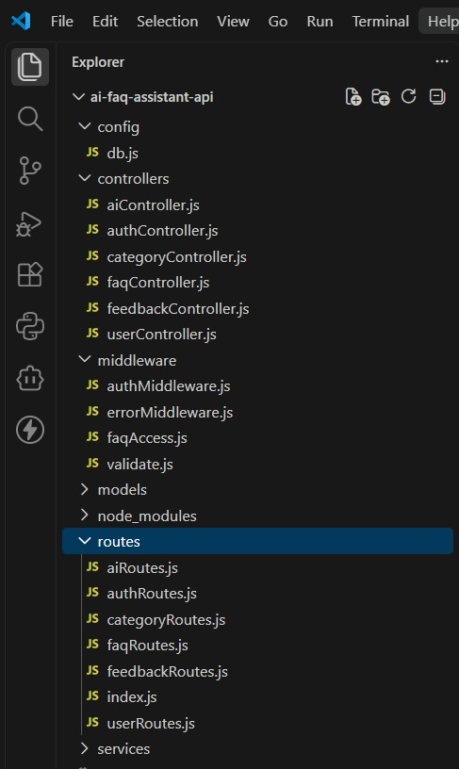

13. API Endpoints
Base API path: /api. The following endpoints are defined in the project route files.
Method | Endpoint | Access | Purpose
GET | / | Public | Returns API status, version, health path and base URL
GET | /health | Public | Health/status response
POST | /api/auth/register | Public | Register a user
POST | /api/auth/login | Public | Authenticate and receive JWT
GET | /api/auth/profile | Authenticated | Return current user profile
GET | /api/faqs | Public / optional auth | List public FAQs; authenticated users also see their own FAQs
GET | /api/faqs/search?q=... | Public / optional auth | Keyword search of visible FAQs
GET | /api/faqs/mine | Authenticated | List FAQs created by current user
GET | /api/faqs/admin/all | Admin | List all FAQs including private records
POST | /api/faqs | Admin / content_creator | Create FAQ
GET | /api/faqs/:id | Public / optional auth | View an FAQ subject to visibility/ownership rules; increments views
PUT | /api/faqs/:id | Owner / admin | Update FAQ
DELETE | /api/faqs/:id | Owner / admin | Delete FAQ
GET | /api/categories | Public | List categories
POST | /api/categories | Admin | Create category
PUT | /api/categories/:id | Admin | Update category
DELETE | /api/categories/:id | Admin | Delete category
POST | /api/ai/generate-faq | Admin / content_creator | Generate and store an AI FAQ
POST | /api/ai/generated/:id/save | Admin / content_creator | Save a generated FAQ into FAQ collection
GET | /api/ai/generated | Admin / content_creator | List generated FAQ records; admin sees all, creator sees own
POST | /api/ai/answer | Authenticated | Generate an answer to a question using public FAQ context
GET | /api/users | Admin | List users
PUT | /api/users/:id | Admin | Update user name, email and role
DELETE | /api/users/:id | Admin | Delete a user except the current admin account
POST | /api/feedback | Authenticated | Submit feedback for an FAQ
GET | /api/feedback | Admin | List feedback

Request validation is implemented for the fields required by each route. Responses use JSON objects with success/message/data-style properties as implemented by the controllers.
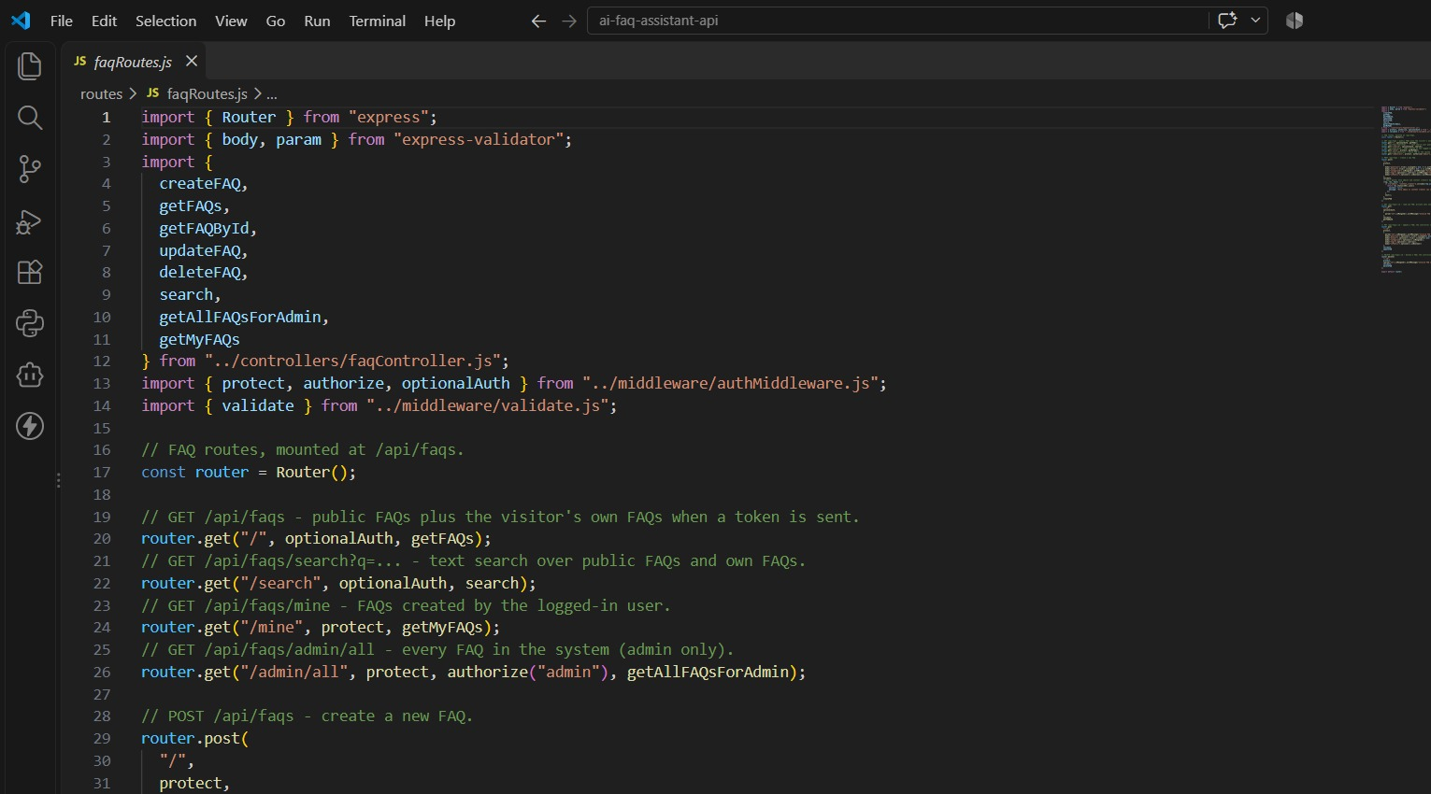
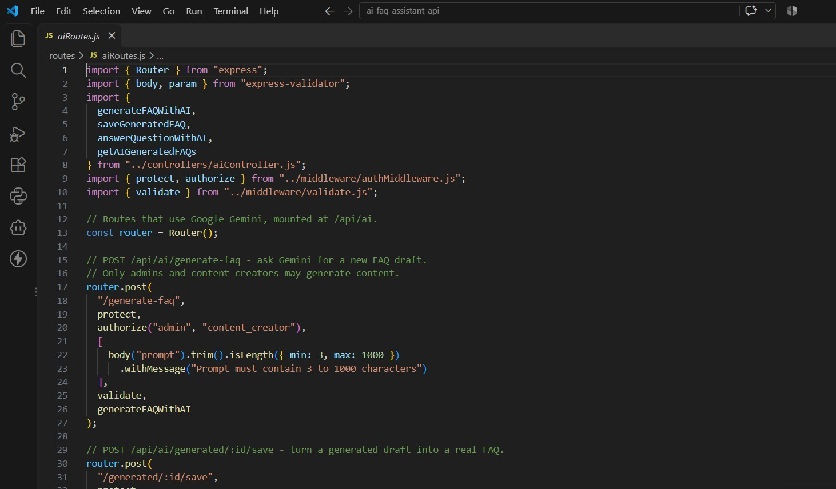
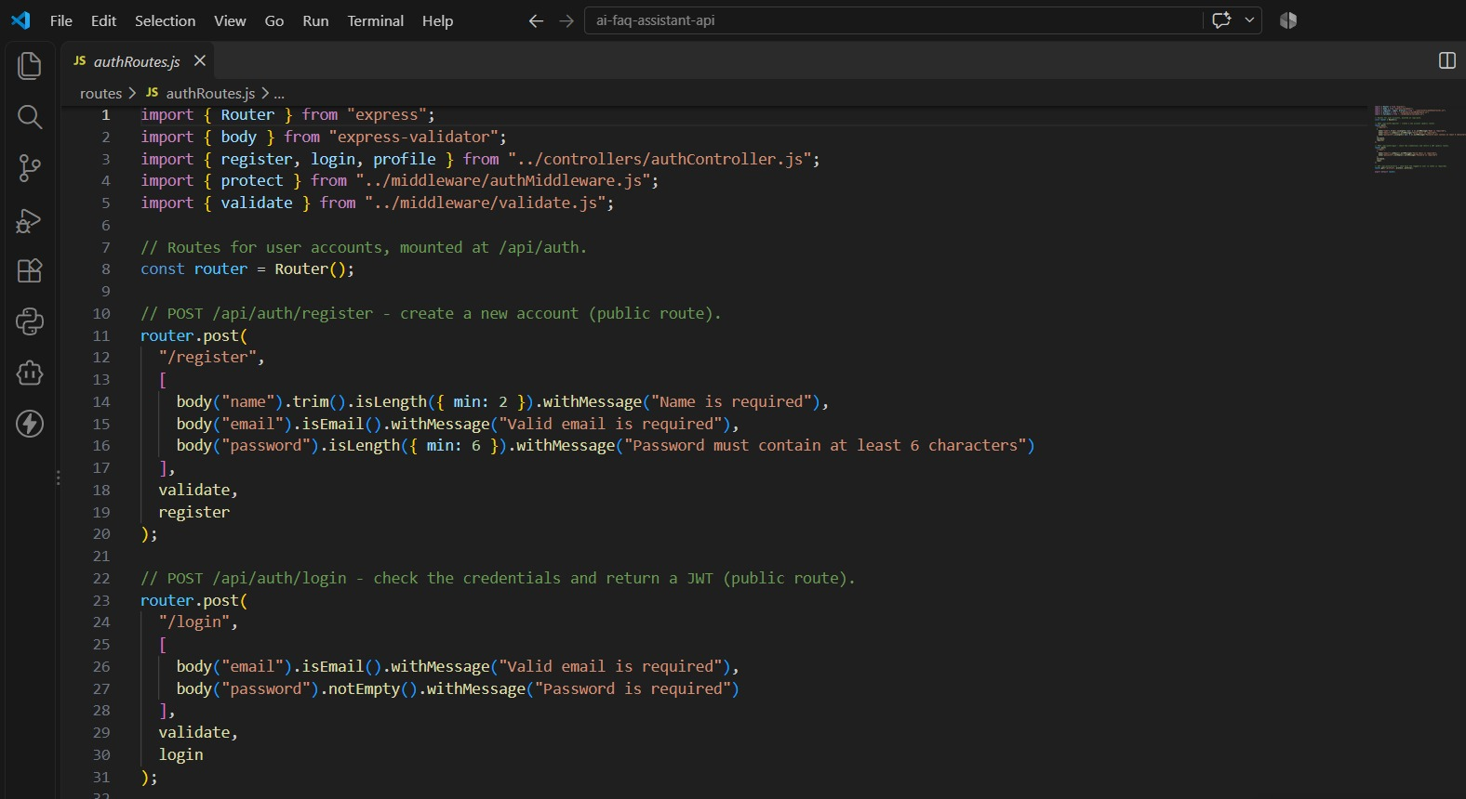

14. Authentication & Authorization
Authentication uses JSON Web Tokens. Registration and login return a JWT containing the userId. Protected requests must send the token using the Bearer authorization scheme.
Authorization: Bearer <JWT_TOKEN>
The protect middleware verifies the token using the configured JWT secret, loads the corresponding user without the password field, and places the user on req.user. Invalid, missing, or expired tokens return HTTP 401.
The authorize middleware checks the authenticated user's role. The roles defined by the User model are admin, content_creator, and user.
Role | Implemented access
admin | Full administrative access including users, categories, all FAQs, feedback and generated FAQ records
content_creator | Create/edit/delete owned FAQs and generate/save AI FAQs
user | View/search public FAQs, generate AI-assisted answers, access own profile
Unauthenticated public user | Access public FAQ/category endpoints and authentication registration/login

Password handling uses bcryptjs. The User schema hashes a password before saving when the password has been modified, and comparePassword is used during login.
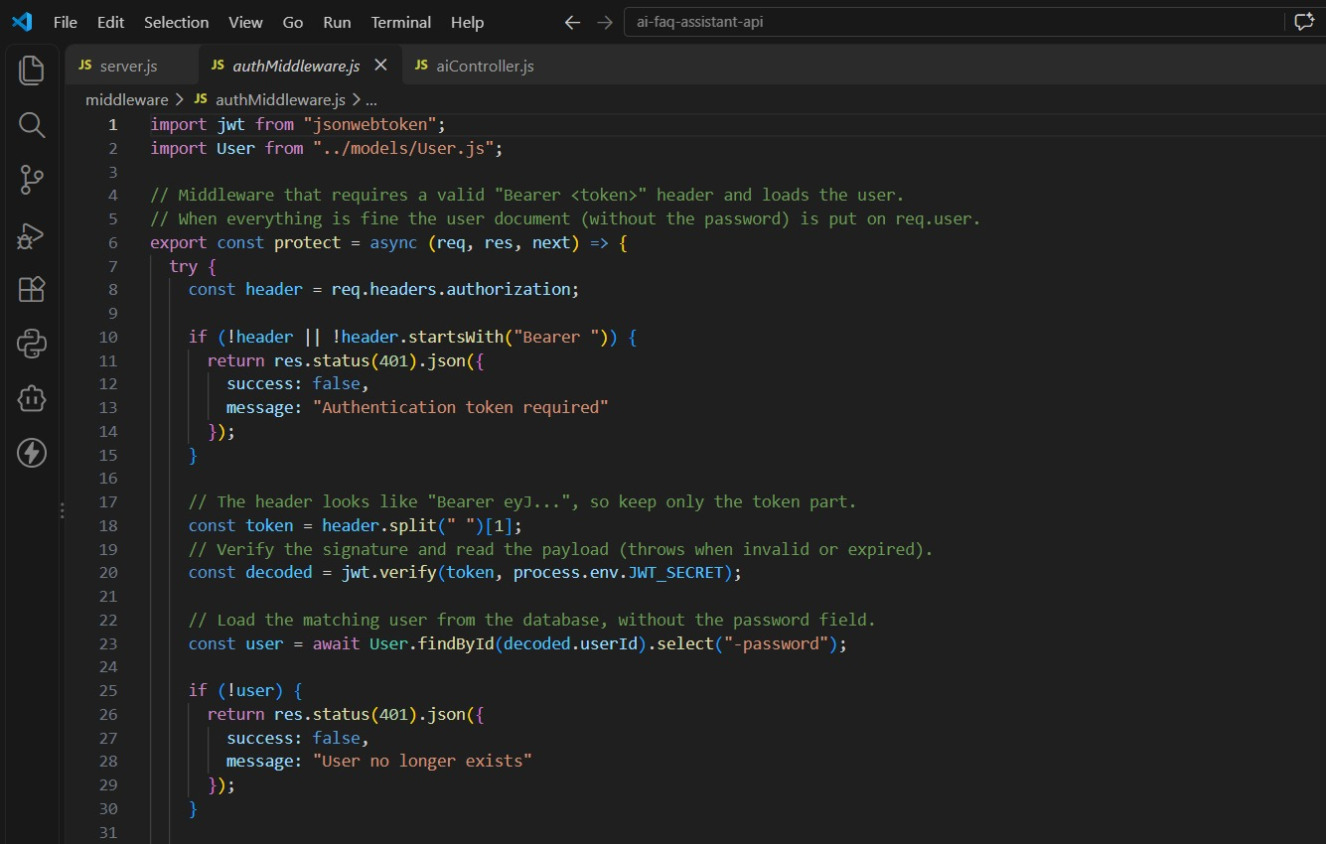

15. AI/Gemini Integration
Google Gemini is integrated in services/geminiService.js using the @google/genai package. The Gemini API key is read from the environment and is not reproduced in this document.
FAQ generation: the generateFAQ function sends a prompt instructing Gemini to create one useful FAQ and return JSON containing question, answer, and topicSuggestions. The response is parsed as JSON and checked for question and answer before it is saved as an AIGeneratedFAQ record.
AI answering: the generateAnswer function sends the user's question together with FAQ context. The AI instruction asks for a clear and brief answer and tells the model not to invent facts when the context is insufficient.
The /api/ai/answer controller obtains up to five matching public FAQs using MongoDB text search, converts them to Q/A context, and passes that context to Gemini. The response contains the original question, generated answer, and contextUsed count.
The configured model can be supplied through GEMINI_MODEL; the code has a default model value when that variable is not provided.
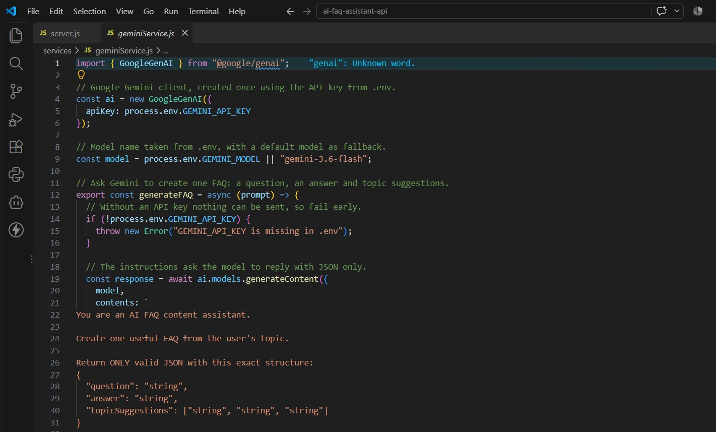

16. FAQ Management
FAQ records contain the creator userId, categoryId, question, answer, tags, public/private status, views and timestamps.
• Create: POST /api/faqs. Only admin and content_creator roles can create FAQs.
• Read: public listings show public FAQs; authenticated users also receive their own FAQs. Admins have a separate endpoint for all FAQs.
• Read by ID: GET /api/faqs/:id. Private FAQs can be viewed by the owner or an admin. Viewing a FAQ increments its views value.
• Update: PUT /api/faqs/:id. Admins can update any FAQ. Content creators can update only their own FAQ records.
• Delete: DELETE /api/faqs/:id. Admins can delete any FAQ; content creators can delete only their own records.
• Tags: tags are normalized and synchronized with Tag and FAQTag records when FAQs are created or updated.
• AI saving: a generated AI FAQ can be saved into the FAQ collection with a category, tags and public/private setting.
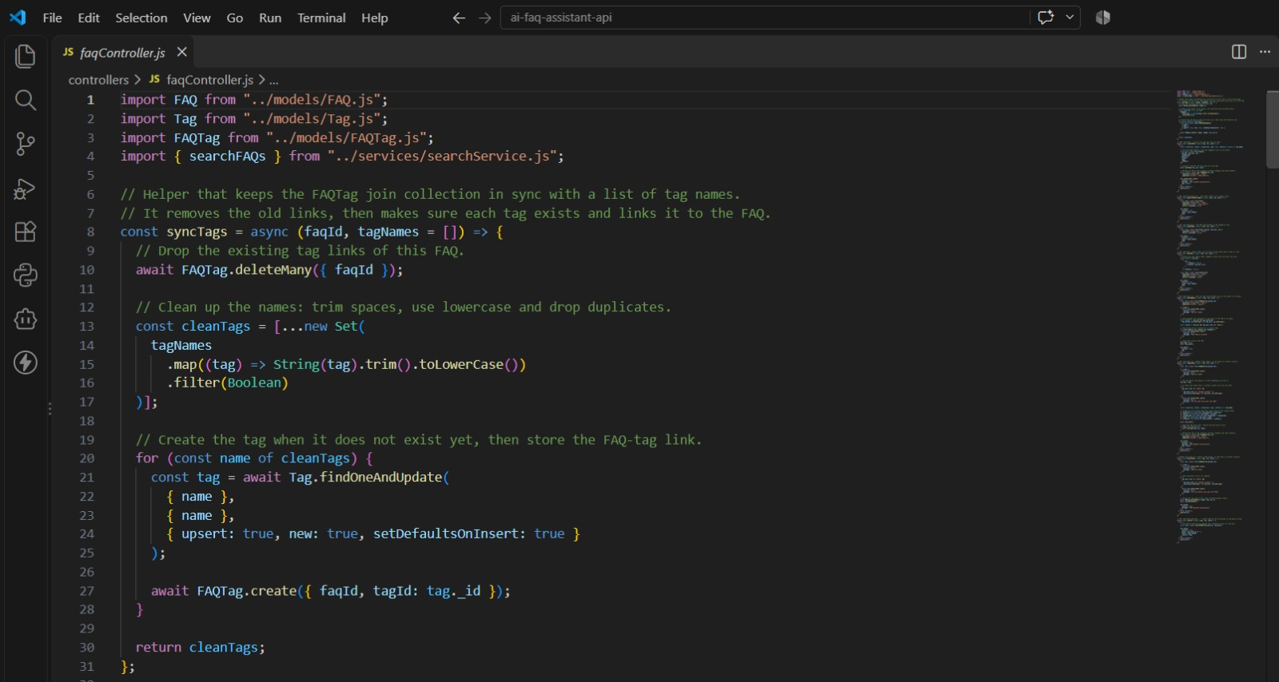

17. Category Management
Category records contain a unique name, optional description, and automatic timestamps.
Operation | Endpoint | Access
List | GET /api/categories | Public
Create | POST /api/categories | Admin
Update | PUT /api/categories/:id | Admin
Delete | DELETE /api/categories/:id | Admin

Each FAQ stores categoryId as a required reference to Category. Category input is validated and Mongoose also enforces the category schema constraints.

18. Search Functionality
The implemented FAQ search is keyword-based, not vector-based semantic search. The search service receives the q query parameter, splits it into words, limits the query to the first ten words, escapes each word for safe regular-expression matching, and searches the question, answer, and tags fields.
For anonymous requests, only public FAQs are included. For authenticated requests, public FAQs and FAQs owned by the authenticated user are included. Results are populated with category and user names, sorted by views and creation date, and limited to 20 records.
The AI answer operation uses a separate MongoDB text search over public FAQs to obtain up to five FAQ records as context for Gemini. This is context retrieval for the AI answer and does not implement vector/embedding semantic search.

19. Project Workflow
The actual workflow can be summarized as follows:
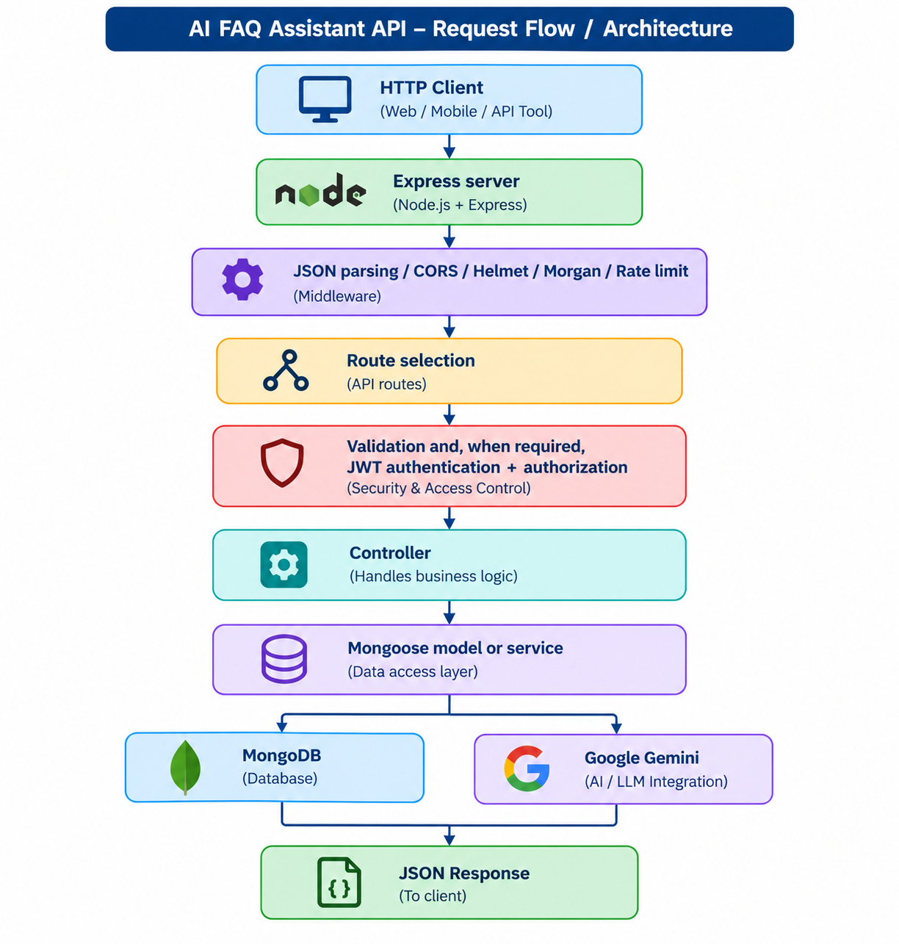Typical FAQ workflow:
1. Register or log in to obtain a JWT.
2. For protected operations, send the JWT as a Bearer token.
3. Create or access categories as permitted by the user's role.
4. Create, read, update, delete, or search FAQs according to visibility and ownership rules.
5. For AI operations, send a prompt or question to the relevant AI endpoint.
6. The controller calls the Gemini service and/or retrieves FAQ context from MongoDB.
7. The API returns the generated result or stored data as JSON.

20. Installation & Setup
1. Install a supported Node.js environment and npm.
2. Extract the project ZIP and open the project root in a terminal or VS Code.
3. Install the project dependencies.
npm install
Create a local .env file using .env.example as the template. Keep real secrets only in the local .env file.
Environment variables referenced by the project include:
MONGO_URI=<your_mongodb_connection_string>
JWT_SECRET=<your_jwt_secret>
JWT_EXPIRES_IN=<your_token_expiry>
GEMINI_API_KEY=<your_gemini_api_key>
GEMINI_MODEL=<your_gemini_model>
CLIENT_URL=<your_client_origin>
PORT=<your_port>
ADMIN_EMAIL=<your_admin_email>
ADMIN_PASSWORD=<your_admin_password>
The actual values are confidential and are not included in this documentation.
Ensure MongoDB is available at the connection represented by MONGO_URI.
If an initial administrator is required, configure the admin environment values locally and run the seed-admin script.

21. Testing
The project includes THUNDER_CLIENT_TESTING.md, which provides a step-by-step API testing sequence. The documented testing approach uses Thunder Client and can also be reproduced in Postman or another HTTP client.
• Registration and login validation.
• JWT-protected profile access.
• Admin-only user and category operations.
• FAQ creation by admin/content_creator.
• FAQ ownership checks during update and delete.
• Public/private FAQ visibility.
• Keyword search.
• AI FAQ generation and saving.
• AI-assisted question answering.
• Feedback submission and admin feedback listing.
• Invalid token, invalid ID, validation, duplicate, not-found and rate-limit responses.
Status | Implemented error condition
400 | Validation failure, invalid ID format, or current admin deletion attempt
401 | Missing/invalid/expired authentication token or invalid login
403 | Insufficient role or access to a private/owned resource
404 | Route or requested resource not found
409 | Duplicate value such as an already registered email or category name
429 | Rate limit exceeded
500 | Unhandled server/database or other internal error

The server applies a rate limit of 200 requests per 15-minute window.

22. Advantages
• Provides a single REST API for FAQ, category, user, AI and feedback operations.
• Uses JWT authentication and role-based authorization for protected operations.
• Hashes passwords before database storage.
• Uses Mongoose schemas and validation to protect database structure.
• Supports public/private FAQ visibility and ownership-based modification.
• Provides keyword search across question, answer and tags.
• Integrates Gemini for AI-assisted FAQ generation and question answering.
• Includes centralized error handling, request logging, security headers, CORS handling and rate limiting.
• Separates routes, controllers, services, middleware and models for clearer backend organization.

23. Limitations
• The uploaded project is backend-only; it does not contain a frontend user interface.
• The FAQ search service is keyword/regular-expression based rather than an embeddings-based vector search implementation.
• AI features depend on access to the configured Google Gemini service and its API credentials.
• The source does not define fixed hardware minimums, so hardware capacity is environment-dependent.
• The API is designed around JSON HTTP requests and does not provide a server-rendered web interface.
• Search results are limited to 20 records, and the search query is limited to the first ten words.

24. Future Enhancements
The following are possible future improvements and are not part of the current implementation:
• Add a frontend interface for administrators, content creators and users.
• Add MongoDB Atlas Vector Search or another embedding-based approach for semantic FAQ similarity.
• Add richer pagination and filtering for large FAQ, user and feedback datasets.
• Add automated API tests and continuous integration.
• Add audit logs for administrative changes.
• Add more detailed analytics for FAQ views, searches and feedback.
• Add stronger lifecycle handling when categories, tags or users are removed.
• Add configurable AI model and response policies through a documented administration interface.

25. Conclusion
The AI FAQ Assistant API is a backend REST application that combines structured FAQ management with authentication, authorization, database persistence, search, feedback, and Google Gemini AI services. The implementation uses Express.js for the API layer, Mongoose for MongoDB access, JWT and bcryptjs for authentication security, and dedicated services for search and Gemini operations. The project provides a clear backend workflow for creating and retrieving FAQ content while restricting administrative and ownership-sensitive operations according to user

26. Reference
• Project source package: AI FAQ Assistant API, including package.json, server.js, routes, controllers, middleware, models, services, configuration and testing documentation.
• Project README.md — installation, architecture, roles, endpoints and example requests.
• THUNDER_CLIENT_TESTING.md — API testing sequence and expected response/status examples.
• Node.js documentation — runtime and npm ecosystem.
• Express.js documentation — REST routing and middleware framework.
• MongoDB documentation — MongoDB database concepts.
• Mongoose documentation — schemas, models, validation and MongoDB integration.
• Google Gemini API / Google GenAI documentation — Gemini model integration.
• jsonwebtoken documentation — JSON Web Token handling.
• bcryptjs documentation — password hashing.
• express-validator documentation — request validation.

Epic 5: Project Executions

Running the API Application
● Install Postman or ThunderClient (VS Code extension).
● Start the backend development server environment parameters:
Bash
npm run dev

API Testing Specification Demo
To verify operational structural integrity via execution endpoints, map endpoints using the configurations below:

1. Identity Onboarding Path Registration
● Route: POST /api/auth/register
● Access: Public
● Payload Request Body JSON:
{
"name": "Priya Sharma",
"email": "priya@writeflow.com",
"password": "securepassword123"
}

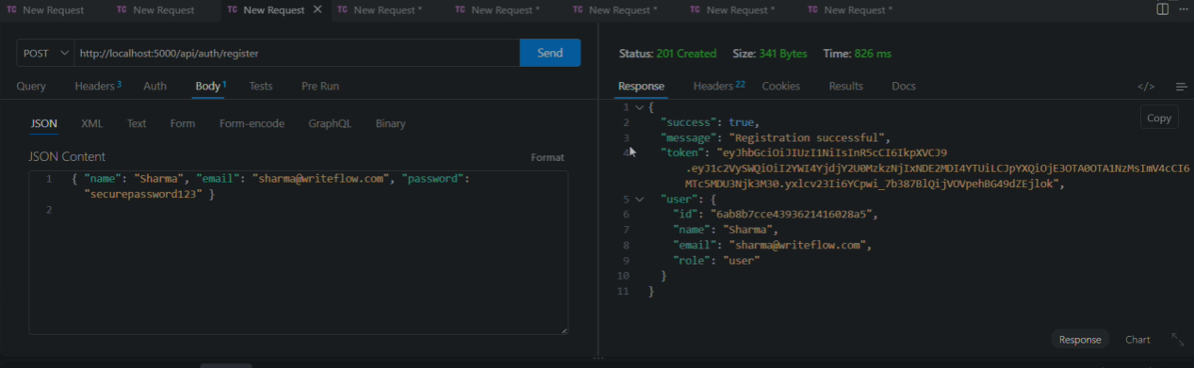

2. Profile Login Verification Quey
● Route: POST /api/auth/login
● Access: Public
● Payload Request Body JSON:
{
"email": "priya@writeflow.com",
"password": "securepassword123"
}
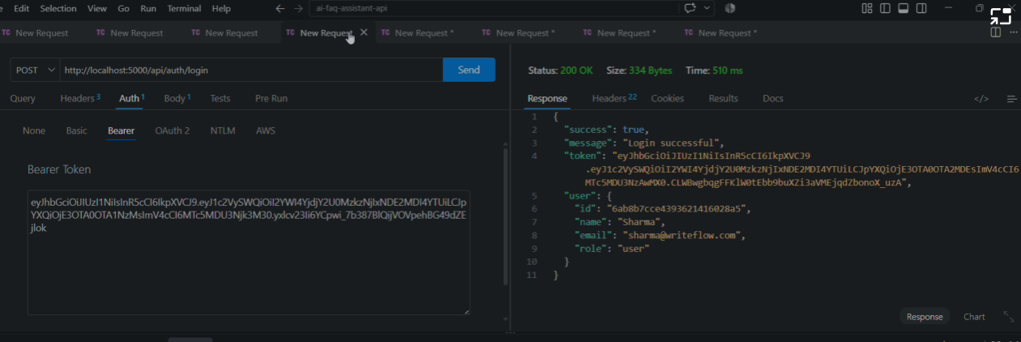

3. Resource Entity Creation (FAQ)
● Route: POST /api/faqs
● Access: Private (Bearer <JWT Token>)
● Payload Request Body JSON:
{
"question": "How do I configure custom category tags?",
"answer": "Navigate to settings panel, append keyword tags arrays, and save schema.",
"category": "Configuration"
}

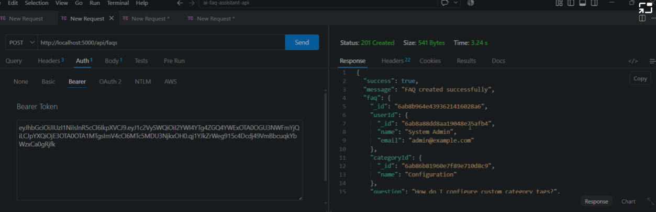

4. Keyword Resource Entity Fetching (Search)
● Route: GET /api/faqs/search?q=configure
● Access: Public
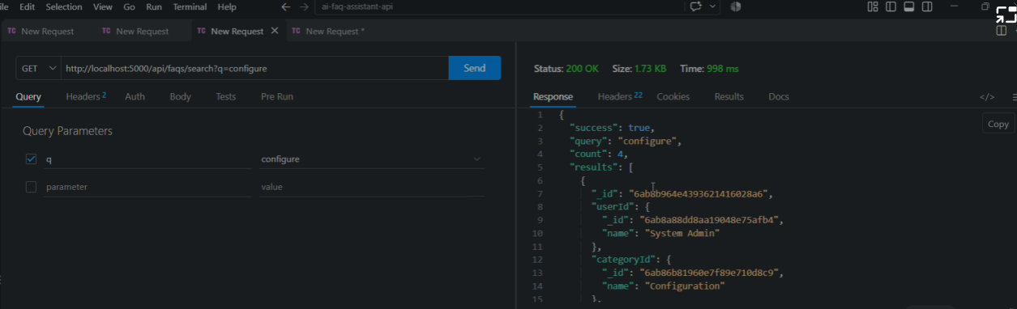

5. AI Intelligent Content Automation (Generate FAQ Pair)
● Route: POST /api/ai/generate-faq
● Access: Private (Bearer <JWT Token>)
● Payload Request Body JSON:
{
"topic": "Mongoose schema indexing validation runtime workflow optimization"
}

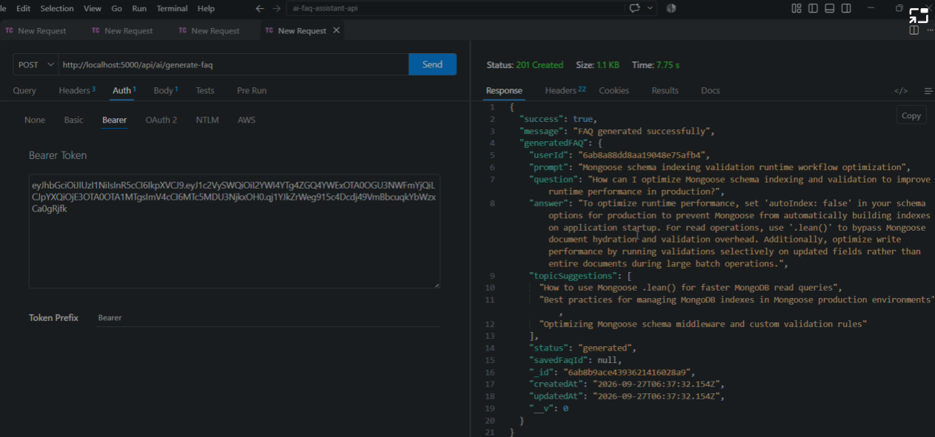

API TESTING VIDEO: https://drive.google.com/file/d/10NG_iZAcXtOvhwLhgaiYOCPt6S9JjYco/view?usp=drivesdk
DEMO LINK: https://drive.google.com/file/d/1K7DG_2YNgoXXM2_vlfsi6fF3NAvMrS0X/view?usp=drivesdk

